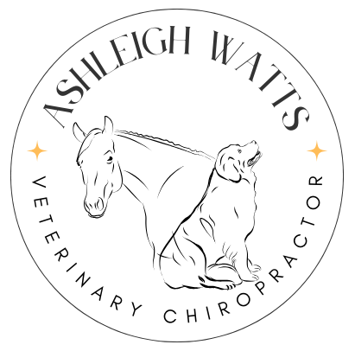
Ashleigh Watts (PGDip, BSc, MAA and RAMP)
Owner:
Address:
Phone number:
Email:

Animals name: Age:
Sex:
Breed:
I declare that I am the legal owner of the above animal and all of the information provided is correct to the best of my knowledge. I have gained consent from our Veterinarian for McTimoney Animal Chiropractic to be carried out on the above animal where they will be treated by Ashleigh Watts of Ashleigh Watts veterinary chiropractor, who is a member of McTimoney Animal Association, Register of Animal Musculoskeletal Practitioners.
Signature of owner: Date:
Veterinary details:
Vet Practice name:
Name of Veterinarian if regularly see a specific Veterinarian:
Vet practice address:
Telephone:
Current diagnosis:

Reason for treatment:

Signature of veterinarian: Date:
Ashleigh Watts works in accordance with the Veterinary Surgeons Act of 1966 and the Veterinary Exemptions order of 2015.

